Supply Chain Cockpit — Project Overview

1. Project Overview
The Supply Chain Cockpit is an executive-level Inventory & Supply Chain Analytics dashboard designed to provide a centralized view of business health, revenue performance, profitability, inventory value, and category performance.
The dashboard brings together multiple dimensions of supply chain and commercial performance, including revenue trends, year-over-year performance, gross profit, margins, stock value, category contribution, zones, sales channels, ABC inventory classification, and supplier geography.
The solution is structured as a five-part analytical journey:
01 Hub → 02 Pulse → 03 Flow → 04 Network → 05 Ledger
The Hub acts as the executive starting point, providing a high-level snapshot of current business health. The subsequent sections are designed to enable deeper analysis of operational performance, movement/flow, network-level insights, and detailed records.
The first page specifically answers the executive question:
“Is the business healthy right now, and how does it compare with last year?”
It combines high-level KPIs with revenue trends, year-over-year comparison, category contribution, and a Revenue vs. Gross Margin performance matrix, allowing decision-makers to quickly identify both strong performance and areas requiring attention.

2. Problem Statement
Supply chain and inventory businesses generate data across multiple dimensions such as sales, inventory, suppliers, categories, regions, channels, and profitability. When these metrics are analyzed separately, it becomes difficult for decision-makers to understand the overall health of the business and identify the factors driving performance.
Traditional reports often answer what happened, but do not provide an integrated view of:
- How current revenue compares with the prior year
- Whether revenue growth is translating into profitability
- How gross margins are performing
- Which categories are contributing the most revenue
- Which categories combine high revenue with strong margins
- How revenue is changing throughout the year
- How performance varies across zones, channels, and categories
- How much value is tied up in inventory/stock
- Where management should focus its attention first
This creates a decision-making gap where executives may have plenty of data but lack a single, intuitive view of business and supply-chain health.
Core Problem
How can fragmented sales, profitability, inventory, category, and supply-chain data be transformed into a single executive cockpit that provides a clear view of current business health and highlights the areas requiring management attention?

3. Solution
The Supply Chain Cockpit addresses this problem through an interactive, executive-focused analytics solution that consolidates key business and supply-chain metrics into a unified dashboard.
The solution provides:
Executive KPIs for Total Revenue, New vs. Prior Year Revenue, Gross Profit YTD, Gross Margin %, and Total Stock Value, giving management an immediate snapshot of financial and inventory health.
Monthly Revenue Analysis tracks revenue throughout the year, making it possible to identify growth patterns, seasonal changes, and periods of unusually strong or weak performance.
Current Year vs. Prior Year Analysis provides a direct comparison of revenue performance, allowing executives to quickly understand whether the business is growing or declining relative to the previous period.
Revenue Breakdown by Category identifies the categories contributing most significantly to revenue and helps prioritize business attention.
Business Performance Matrix combines Total Revenue and Gross Margin % to identify categories that are not only generating revenue but also delivering healthy profitability.
Interactive Filters for Year, Zone, Channel, Category, ABC Class, and Supplier Country allow users to move from an enterprise-level view to a more specific business context.

Page 1 — 01 Hub: Executive Overview

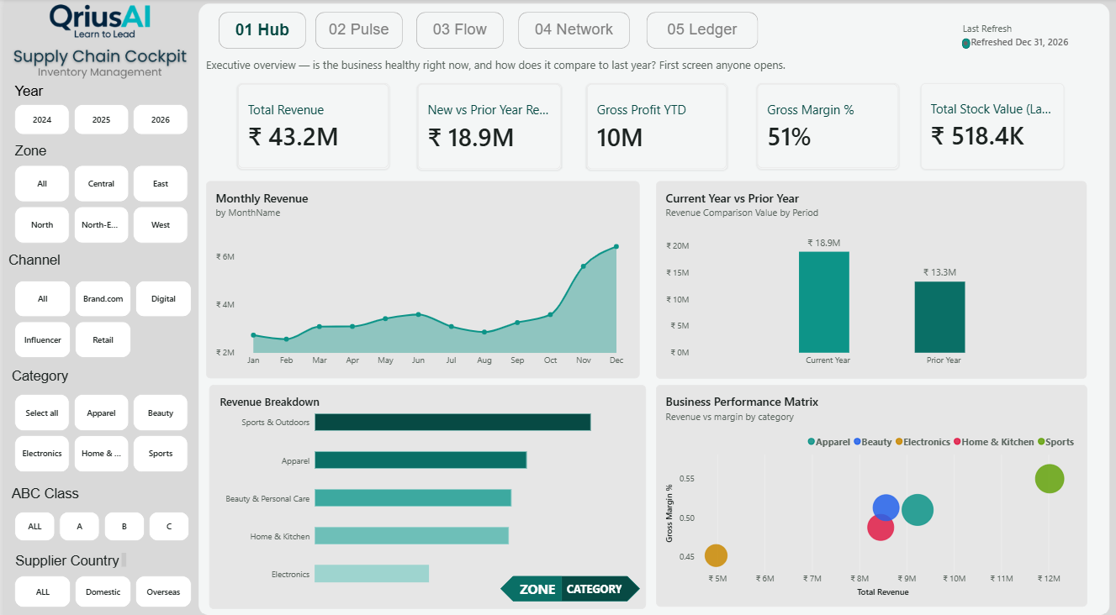
1. Page Overview
The 01 Hub is the first and most important page of the Supply Chain Cockpit. It is designed as an executive health-check dashboard, giving decision-makers a consolidated view of the organization's current financial and operational position.
The page brings together revenue, year-over-year growth, profitability, inventory value, monthly performance, category contribution, and margin analysis into a single view.
Its primary purpose is to answer:
“Is the business healthy right now, what is driving its performance, and how does it compare with the previous year?”

2. Business Problem
Supply chain businesses generate large amounts of data across sales, inventory, profitability, categories, regions, and channels. When these metrics are viewed separately, executives may have difficulty understanding the overall business position.
A high revenue figure alone does not necessarily indicate a healthy business. Management also needs to understand whether revenue is growing, profitable, sustainable, and supported by the right categories.
Key Challenges
- Revenue and profitability are often analyzed separately.
- Year-over-year performance is not immediately visible.
- Category contribution may be understood without considering margins.
- Monthly revenue patterns can be difficult to identify from static reports.
- Inventory value needs to be considered alongside sales performance.
- Executives may need to navigate multiple reports to understand the complete picture.
- It can be difficult to identify which business areas require immediate attention.
Core Problem
How can sales, profitability, inventory, and category performance be brought together into a single executive view that quickly reveals the current health of the business and the key drivers behind performance?

3. Objective
The objective of the 01 Hub is to provide a single-screen executive overview of business performance.
It is designed to help management:
- Monitor overall revenue and profitability.
- Compare current performance with the previous year.
- Track monthly revenue movement.
- Identify major revenue-generating categories.
- Evaluate revenue alongside gross margin.
- Monitor the financial value of inventory.
- Drill into performance by Year, Zone, Channel, Category, ABC Class, and Supplier Country.
The goal is to enable executives to identify important business signals quickly without going through detailed operational reports first.

4. Story of the Page
The page follows a clear Executive → Performance → Drivers → Investigation story.
Step 1 — Establish Business Health
The page begins with five executive KPIs:
Total Revenue → Revenue Growth → Gross Profit → Gross Margin → Stock Value
These metrics provide an immediate snapshot of the business's financial and inventory health.

Step 2 — Understand Revenue Movement
The Monthly Revenue chart shows how revenue changes throughout the year.
The increasing revenue toward November and December highlights a strong year-end acceleration and indicates that revenue is not evenly distributed across the year.

Step 3 — Benchmark Against Last Year
The Current Year vs Prior Year visual provides the historical benchmark.
The current year shows approximately ₹18.9M compared with ₹13.3M in the prior year, indicating stronger revenue performance in the current period.
This answers:
“Are we actually growing?”

Step 4 — Identify Revenue Drivers
The Revenue Breakdown visual moves from overall performance to category-level contribution.
It shows which categories are responsible for the largest share of revenue, helping management understand where the business is generating its sales.

Step 5 — Evaluate Revenue Quality
Revenue alone is not enough.
The Business Performance Matrix compares Total Revenue and Gross Margin %, allowing management to identify categories that combine sales scale with profitability.
This changes the question from:
“Which category sells the most?”
to:
“Which category generates strong revenue while maintaining a healthy margin?”

Step 6 — Move to Focused Analysis
The filters for Year, Zone, Channel, Category, ABC Class, and Supplier Country allow users to investigate the business from different perspectives.
For example, an executive can move from:
Overall Business → Specific Zone → Specific Channel → Specific Category
without leaving the dashboard.

5. Key Business Insights
The page provides several important executive-level insights:
- Revenue is showing positive growth, with current-year revenue outperforming the prior-year comparison.
- Year-end months show stronger revenue momentum, particularly toward November and December.
- Sports & Outdoors is the leading revenue contributor in the current category view.
- Gross Margin of approximately 51% indicates that the business is generating a substantial margin alongside its revenue.
- Revenue and profitability can be evaluated together through the Business Performance Matrix, preventing decisions based solely on sales volume.
- Inventory value of approximately ₹518.4K provides an additional perspective on capital tied up in stock.
- The combination of revenue, margin, category, and inventory metrics provides a more complete picture of business health than any individual KPI.

KPI Descriptions

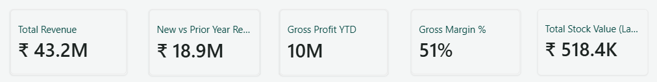

Total Revenue — Shows the overall revenue generated during the selected period.
New vs Prior Year Revenue — Shows the revenue generated in the current year compared with the prior year.
Gross Profit YTD — Shows the total gross profit generated year-to-date.
Gross Margin % — Shows the percentage of revenue retained as gross profit after costs.
Total Stock Value — Shows the total monetary value of the current inventory/stock.

Monthly Revenue

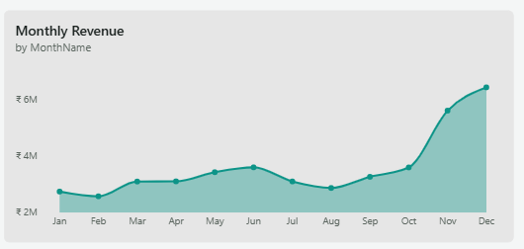

What the visual shows
The Monthly Revenue area chart shows how revenue changes across each month of the selected period. It highlights the overall monthly pattern, including relatively stable performance through most of the year and a significant increase in revenue during November and December.
Why it is selected/included
This visual is included to identify monthly revenue trends, seasonal patterns, and periods of strong or weak business performance. It helps management understand when revenue accelerates and provides useful context for planning inventory, supply, promotions, and sales activities.
What happens when clicked
When a user clicks on a specific month, that month is selected and the connected visuals on the page can cross-filter or cross-highlight according to the dashboard's interaction settings. This allows users to investigate the selected month's revenue contribution, category performance, profitability, and other business metrics in greater detail.
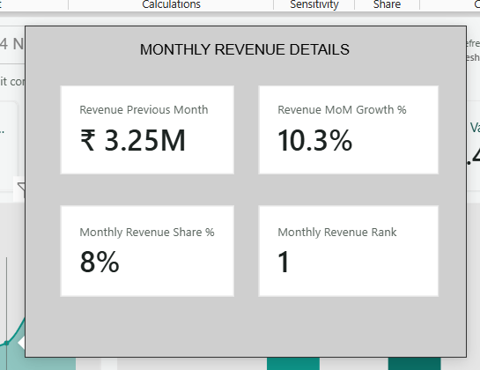

Tooltip
Tooltip Purpose
A custom Monthly Revenue Details tooltip has been added to provide deeper context when the user hovers over a specific month in the revenue trend.
It displays four supporting metrics:
- Revenue Previous Month — Shows the revenue generated in the preceding month for comparison.
- Revenue MoM Growth % — Shows the percentage change in revenue compared with the previous month.
- Monthly Revenue Share % — Shows the selected month's contribution to the overall revenue.
- Monthly Revenue Rank — Indicates the selected month's revenue ranking compared with other months.
Why the tooltip is included
The tooltip prevents the main chart from becoming overloaded with information while still allowing users to perform a deeper month-level analysis. Instead of seeing only the revenue value, users can understand growth, contribution, and relative performance for the selected month.
What happens when interacted with
When the user hovers over a month, the custom tooltip dynamically updates to display the detailed metrics for that particular month. This creates a contextual drill-down experience without requiring an additional visual or page navigation.

Current Year vs Prior Year

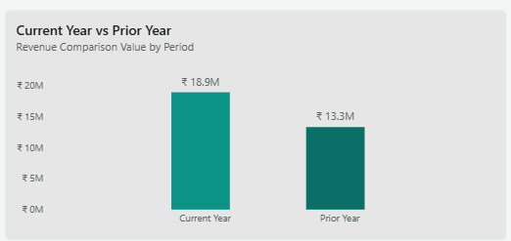

What the visual shows
The clustered column chart compares revenue between the Current Year (₹18.9M) and Prior Year (₹13.3M), providing a direct view of year-over-year revenue performance.
Why it is selected/included
This visual is included to quickly determine whether the business is growing or declining compared with the previous year. The comparison shows that current-year revenue is higher, giving management a clear benchmark for evaluating business growth.
What happens when clicked
When the user clicks on either Current Year or Prior Year, the selected period is highlighted and connected visuals can cross-filter or cross-highlight based on the selected year. This allows users to investigate the revenue drivers and performance patterns associated with that period.

Revenue Breakdown — Bookmark Selection

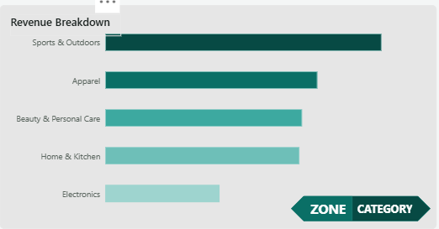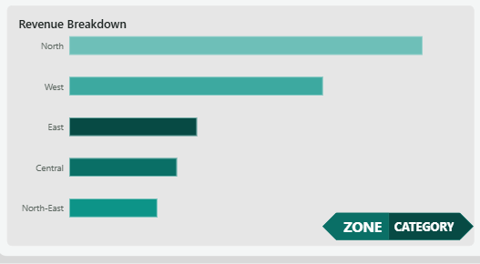

What the visual shows
The Revenue Breakdown visual displays revenue by two different business dimensions: Category and Zone. The Category view shows revenue contribution from categories such as Sports & Outdoors, Apparel, Beauty & Personal Care, Home & Kitchen, and Electronics, while the Zone view shows revenue across North, West, East, Central, and North-East.
Why it is selected/included
The visual is included to provide two complementary perspectives on revenue performance without occupying additional dashboard space. Category analysis helps identify which product categories drive revenue, while Zone analysis helps identify the strongest geographic markets. This makes the page more interactive and allows executives to switch between “What are we selling?” and “Where are we selling?”
What happens when clicked
The ZONE / CATEGORY bookmark buttons allow the user to switch between the two views. Clicking CATEGORY displays the revenue breakdown by product category, while clicking ZONE changes the same visual to show revenue by geographic zone. The bookmark changes the visual state without navigating to another page, keeping the analysis within the same executive view.
Business Performance Matrix

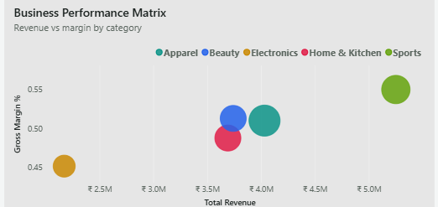

What the visual shows
The Business Performance Matrix is a bubble chart that compares each product category based on Total Revenue on the X-axis and Gross Margin % on the Y-axis. It allows categories such as Apparel, Beauty, Electronics, Home & Kitchen, and Sports to be evaluated simultaneously on both revenue scale and profitability.
Why it is selected/included
The visual is included because revenue alone does not define business performance. A category may generate high sales but have a lower margin, while another may generate moderate revenue with stronger profitability. This matrix helps management identify categories that offer the best combination of revenue contribution and margin performance, supporting better category-level business decisions.
What happens when clicked
When the user clicks on a category bubble, that category is highlighted and the connected visuals can cross-filter or cross-highlight based on the selected category. This allows users to investigate the selected category's revenue contribution, monthly performance, zone performance, and other business metrics in greater detail.

Page 2 — 02 Pulse: Sales & Margin Deep-Dive

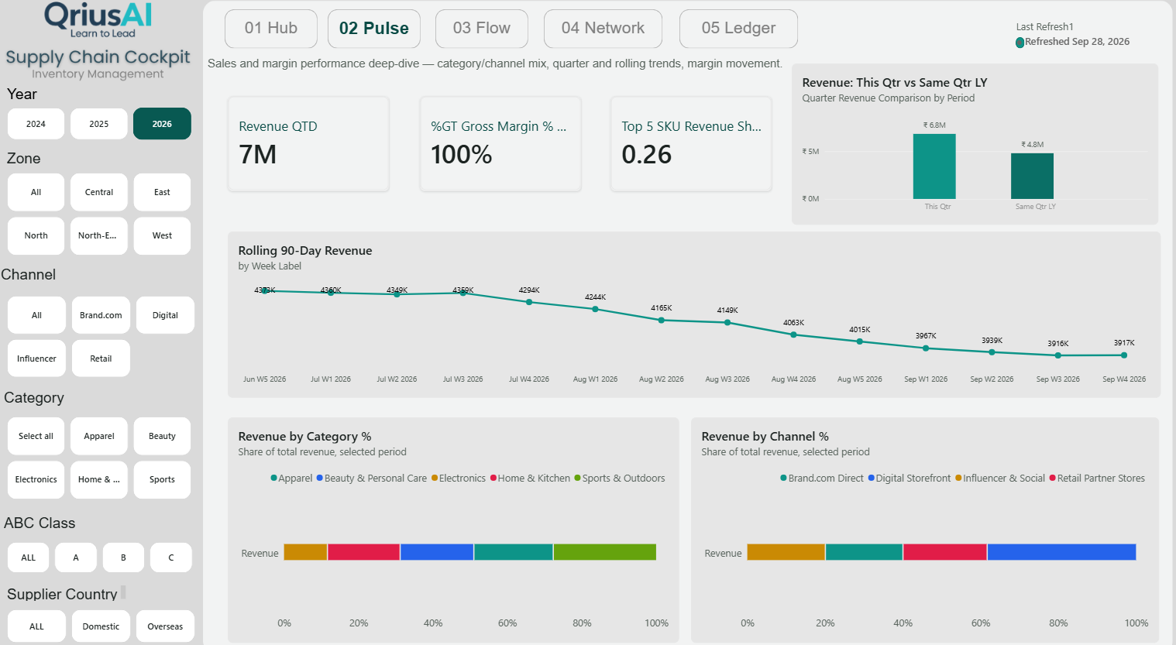

We can structure Page 2 for the case study in the same way as Page 1:
Page Overview
The 02 Pulse page is designed as a deeper performance-analysis layer after the executive overview. While 01 Hub answers “Is the business healthy?”, this page focuses on:
“What is driving current sales performance, and how are revenue mix and margins moving?”
It analyzes quarterly performance, rolling 90-day revenue, category mix, channel mix, and margin-related KPIs.
Business Questions This Page Answers
- How is current-quarter revenue performing against the same quarter last year?
- What is the recent 90-day revenue trend?
- Which categories contribute the largest share of revenue?
- Which sales channels contribute most to revenue?
- How concentrated is revenue among the top 5 SKUs?
- How is the business performing under the selected year, zone, channel, category, ABC class, and supplier country filters?
- Are changes in revenue accompanied by changes in the gross-margin position?

Page Story
The page follows a Current Performance → Recent Momentum → Revenue Mix → Channel Mix story.
1. Start with current performance
The top KPIs establish the current-quarter position through Revenue QTD, gross-margin performance, and Top 5 SKU revenue share.
2. Benchmark current performance
The This Quarter vs Same Quarter Last Year visual establishes whether current-quarter revenue is ahead of or behind the comparable period.
3. Look at recent momentum
The Rolling 90-Day Revenue trend provides a more granular view of recent sales movement, helping identify periods of acceleration, decline, and recovery.
4. Understand category mix
The Revenue by Category % visual shows how the total revenue pool is distributed across categories. This shifts the analysis from “how much are we selling?” to “what is our revenue made of?”
5. Understand channel mix
The Revenue by Channel % visual shows how revenue is distributed across Brand.com Direct, Digital Storefront, Influencer & Social, and Retail Partner Stores.
So the analytical journey becomes:
Current Quarter → Year-over-Year Benchmark → Recent Momentum → Category Mix → Channel Mix
Problem Statement
Although the first page provides an executive snapshot of business health, management still needs to understand what is driving the current performance and how the revenue mix is changing.
A single revenue number cannot explain whether performance is being driven by recent momentum, particular categories, specific sales channels, or a concentrated group of SKUs. Similarly, quarter-over-quarter or year-over-year comparisons alone may hide short-term changes in business momentum.
Core Problem
How can current sales performance be analyzed beyond headline revenue to identify recent momentum, year-over-year movement, category contribution, channel contribution, and revenue concentration?
Solution
The 02 Pulse page provides an interactive sales and margin deep-dive by combining quarterly comparison, rolling 90-day revenue trends, category revenue mix, channel revenue mix, and supporting KPIs.
This allows decision-makers to move from:
“Revenue is ₹X”
to:
“Revenue is moving this way, these categories and channels are driving it, and this is how concentrated the revenue is.”
That makes 02 Pulse the analytical bridge between the executive health check of 01 Hub and the deeper operational analysis that follows in the Supply Chain Cockpit.

Page 2 — KPI Descriptions

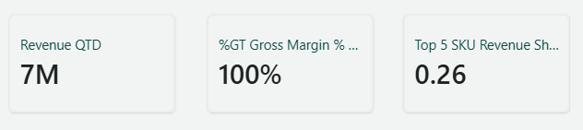

Revenue QTD — Shows the total revenue generated quarter-to-date, providing a view of current-quarter sales performance.
%GT Gross Margin % — Shows the gross margin percentage performance against the relevant target or benchmark, helping assess whether profitability is tracking at the expected level.
Top 5 SKU Revenue Share — Shows the proportion of total revenue contributed by the top five SKUs, indicating the level of revenue concentration among the highest-performing products.

Rolling 90-Day Revenue

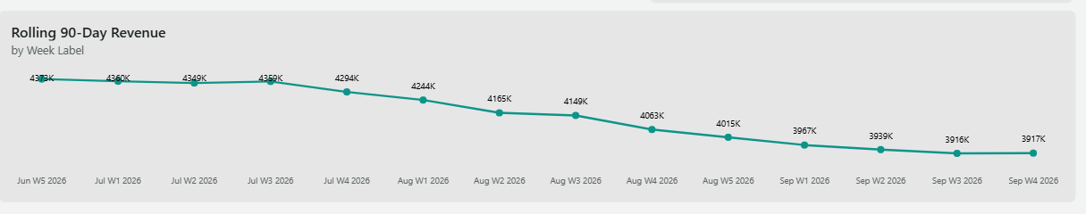
What the visual shows
This line chart tracks rolling 90-day revenue across weekly periods, showing how recent revenue performance changes over time. The trend moves from approximately ₹4.37M in Jun W5 2026 to ₹3.92M by Sep W4 2026, indicating a gradual decline in rolling revenue during the displayed period.
Why it is selected/included
The visual is included to monitor short-term revenue momentum using a rolling 90-day window. Unlike a monthly or annual view, it smooths short-term fluctuations and helps identify whether the business is experiencing a sustained upward, stable, or downward revenue trend.
What happens when clicked
When the user clicks on a specific week, that period is selected and connected visuals can cross-filter or cross-highlight according to the dashboard's interaction settings. This allows the user to investigate the category, channel, or other business factors associated with the selected period.

Revenue: This Qtr vs Same Qtr LY

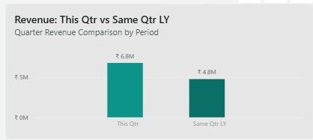

What the visual shows
This clustered column chart compares revenue generated in the current quarter (₹6.8M) with revenue from the same quarter last year (₹4.8M). It provides a direct year-over-year view of quarterly sales performance.
Why it is selected/included
The visual is included to measure current-quarter growth against a consistent historical benchmark. Comparing the same quarter avoids misleading comparisons caused by seasonal differences and helps management quickly determine whether current performance is improving.
What happens when clicked
When the user clicks either This Qtr or Same Qtr LY, the selected period is highlighted and the connected visuals can cross-filter or cross-highlight based on the selected period. This allows users to investigate the category, channel, revenue trend, and other performance drivers behind the selected quarter.

Revenue by Category %

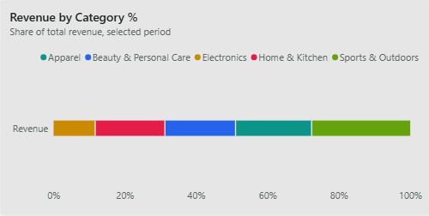
What the visual shows
This 100% stacked bar chart shows the percentage contribution of each product category to the total revenue for the selected period. It compares the revenue mix across Apparel, Beauty & Personal Care, Electronics, Home & Kitchen, and Sports & Outdoors, with the complete bar representing 100% of revenue.
Why it is selected/included
The visual is included to understand the composition of revenue rather than only the total revenue generated. It helps management identify which categories have the largest share of sales and assess whether the business is overly dependent on particular categories. It also makes category-mix changes easier to identify when filters such as year, zone, or channel are applied.
What happens when clicked
When the user clicks on a category segment, that category is highlighted and the connected visuals can cross-filter or cross-highlight based on the selected category. This allows users to investigate the selected category's revenue performance, channel contribution, recent trends, and other related business metrics.

Revenue by Channel %

e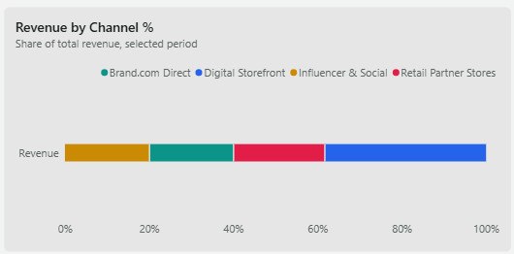

What the visual shows
This 100% stacked bar chart shows how total revenue is distributed across the different sales channels for the selected period. It compares the contribution of Brand.com Direct, Digital Storefront, Influencer & Social, and Retail Partner Stores, with the complete bar representing 100% of revenue.
Why it is selected/included
The visual is included to understand the revenue mix across sales channels and identify which channels contribute most to overall sales. This helps management evaluate channel dependency, understand the importance of digital and direct channels, and identify opportunities to strengthen or rebalance the sales-channel portfolio.
What happens when clicked
When the user clicks on a channel segment, the selected channel is highlighted and the connected visuals can cross-filter or cross-highlight based on that channel. This allows users to examine the selected channel's revenue performance, category contribution, recent revenue trend, and other business metrics.

Page 3 — 03 Flow: Inventory Health & Replenishment

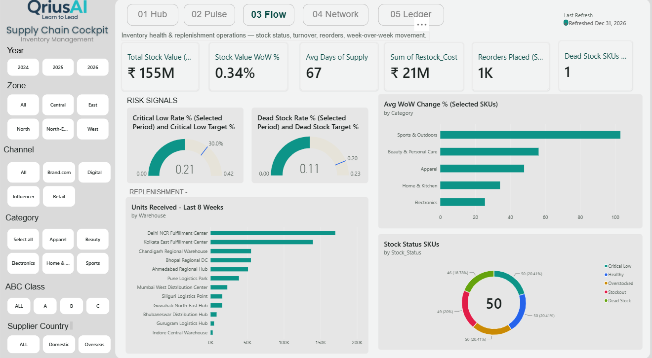

1. Page Overview
The 03 Flow page focuses on the operational side of inventory management. While 01 Hub provides the overall business health and 02 Pulse explains sales and margin movement, 03 Flow answers:
“Do we have the right inventory levels, and are replenishment activities keeping stock healthy?”
The page brings together stock value, inventory movement, days of supply, restocking costs, reorder activity, dead stock, inventory risk signals, warehouse receipts, SKU movement, and stock-status distribution.
It provides management with a consolidated view of whether inventory is available, moving efficiently, and being replenished at the right time.

2. Business Problem
Inventory management requires balancing two opposing risks:
- Too little stock can lead to stockouts and lost sales.
- Too much or slow-moving stock can tie up capital and increase holding costs.
When inventory metrics such as stock value, days of supply, reorder activity, dead stock, and warehouse receipts are analyzed separately, it becomes difficult to determine the actual health and flow of inventory.
Management needs to understand:
- How much capital is currently tied up in inventory?
- Is inventory value increasing or decreasing?
- How many days of supply are available?
- How much is being spent on restocking?
- How frequently are reorders being placed?
- Are there critical-low or dead-stock risks?
- Which categories are experiencing significant stock movement?
- Which warehouses are receiving the most inventory?
- What proportion of SKUs are healthy, critical, overstocked, stockout, or dead stock?
Core Problem
How can inventory health and replenishment activity be monitored together to identify stock risks, improve inventory flow, and ensure the right products are available at the right time?

3. Objective
The objective of 03 Flow is to provide an operational view of inventory health and replenishment performance.
The page is designed to help decision-makers:
- Monitor overall stock value.
- Track week-over-week inventory movement.
- Understand available days of supply.
- Monitor restocking costs and reorder activity.
- Identify critical-low and dead-stock risks.
- Analyze inventory movement by category.
- Monitor warehouse-level inventory receipts.
- Understand the distribution of SKU stock statuses.
- Identify areas requiring replenishment or inventory optimization.
The ultimate objective is to support a balance between product availability and inventory efficiency.

4. Business Questions Answered
Inventory Position
How much inventory value are we currently holding?
The Total Stock Value KPI provides the monetary value of inventory under the selected context.
Inventory Movement
Is stock value changing week over week?
The Stock Value WoW % KPI indicates the recent movement in inventory value.
Stock Availability
How many days of supply do we currently have?
The Average Days of Supply KPI provides an indication of how long current inventory can potentially support demand.
Replenishment
How much are we spending on restocking and how many reorders are being placed?
The Restock Cost and Reorders Placed KPIs provide visibility into replenishment activity.
Inventory Risk
Are there products at risk of becoming unavailable or remaining unsold?
The Critical Low Rate and Dead Stock Rate gauges identify inventory risk against defined targets.
Category Movement
Which categories are experiencing the greatest inventory movement?
The Average WoW Change % by Category visual identifies categories with stronger or weaker week-over-week stock movement.
Warehouse Flow
Which warehouses are receiving the most inventory?
The Units Received — Last 8 Weeks visual compares inventory received across warehouses.
SKU Health
What is the current health of the SKU portfolio?
The Stock Status SKUs donut shows the distribution of SKUs across statuses such as Critical Low, Healthy, Overstocked, Stockout, and Dead Stock.

5. Story of the Page
The page follows an Inventory Position → Risk → Movement → Replenishment → Stock Health story.
Step 1 — Establish the Inventory Position
The top KPIs provide the initial inventory health check:
Stock Value → WoW Movement → Days of Supply → Restock Cost → Reorders → Dead Stock
This immediately establishes how much inventory is being held and how actively it is being managed.

Step 2 — Identify Inventory Risks
The Risk Signals section focuses on two critical inventory problems:
Critical Low Rate identifies the proportion of selected inventory that is approaching critically low levels.
Dead Stock Rate highlights inventory that is not moving and may represent tied-up capital.
This shifts the analysis from:
“How much stock do we have?”
to:
“Is our stock healthy?”

Step 3 — Understand Category-Level Movement
The Avg WoW Change % by Category visual identifies which categories are experiencing the greatest changes in inventory levels.
This can help management investigate whether movement is caused by demand changes, replenishment activity, or inventory buildup.

Step 4 — Track Replenishment Flow
The Units Received — Last 8 Weeks visual provides visibility into inventory flowing through the warehouse network.
It helps identify which warehouses are receiving the largest quantities and provides an operational perspective on where replenishment activity is concentrated.

Step 5 — Evaluate Overall SKU Health
The Stock Status SKUs visual summarizes the current inventory portfolio across different stock conditions.
This gives management a final health check:
How much of our SKU portfolio is healthy versus at risk or potentially inefficient?

6. Overall Page Takeaway
The 03 Flow page connects inventory levels with inventory movement and replenishment activity.
The analytical journey is:
How much stock do we have?
↓
Is stock changing?
↓
Do we have enough supply?
↓
Where are the risks?
↓
How is inventory flowing through warehouses?
↓
What is the overall health of our SKUs?

Page 3 — KPI Descriptions

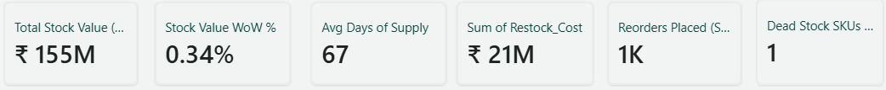

Total Stock Value — Shows the total monetary value of inventory currently held within the selected analysis period.
Stock Value WoW % — Shows the week-over-week percentage change in stock value, helping track recent inventory movement.
Avg Days of Supply — Shows the average number of days the available inventory can support expected demand, indicating overall stock coverage.
Sum of Restock Cost — Shows the total cost incurred for restocking inventory, providing visibility into replenishment expenditure.
Reorders Placed — Shows the number of reorder actions placed during the selected period, indicating replenishment activity.
Dead Stock SKUs — Shows the number of SKUs identified as dead stock, highlighting products with little or no movement and potential tied-up inventory.

Risk Signals
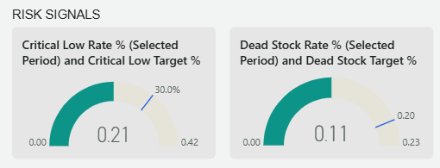

What the visual shows
The Risk Signals section uses two gauge charts to monitor inventory risk: Critical Low Rate and Dead Stock Rate. The first gauge shows the current critical-low rate at approximately 0.21, against a target of 30%, while the second shows a dead-stock rate of approximately 0.11, against a target of 0.20.
Why it is selected/included
These gauges are included to provide a quick risk assessment of inventory health. Instead of looking only at total stock value, they help management identify whether inventory is moving toward two important operational risks: insufficient stock availability and excess/obsolete inventory. The target markers also provide a benchmark for evaluating whether the current risk level is within the desired range.
What happens when clicked
When the user interacts with the gauge or its associated data point, the selected inventory-risk context can interact with the other visuals through filtering or highlighting, depending on the dashboard configuration. This allows users to investigate the categories, SKUs, or inventory areas contributing to the identified risk.

Avg WoW Change % — Selected SKUs

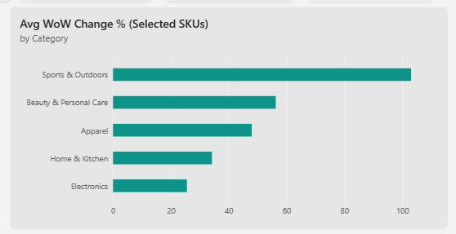

What the visual shows
This horizontal bar chart compares the average week-over-week change in selected SKU inventory levels across categories. It shows the strongest movement in Sports & Outdoors, followed by Beauty & Personal Care, Apparel, Home & Kitchen, and Electronics.
Why it is selected/included
The visual is included to identify which product categories are experiencing the largest changes in inventory levels. This helps the business understand where inventory is moving most rapidly and where replenishment, demand changes, or stock-level adjustments may require closer attention.
What happens when clicked
When the user clicks on a category bar, that category is highlighted and the connected visuals can cross-filter or cross-highlight based on the selected category. This allows users to investigate the selected category's stock status, replenishment activity, risk signals, and inventory position in greater detail.

Units Received — Last 8 Weeks

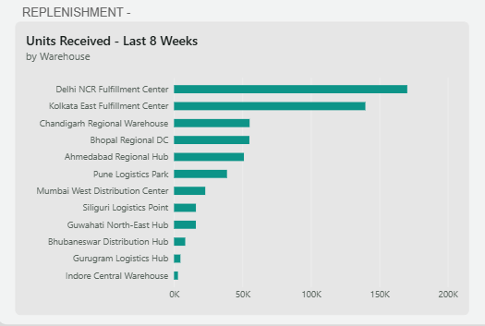
What the visual shows
This horizontal bar chart shows the total number of inventory units received by each warehouse during the last eight weeks. It compares inbound inventory across the warehouse network, with Delhi NCR Fulfillment Center receiving the highest volume, followed by Kolkata East Fulfillment Center and other regional warehouses.
Why it is selected/included
The visual is included to understand the flow and distribution of incoming inventory across warehouses. It helps identify which locations are handling the highest replenishment volumes and provides operational context for evaluating inventory availability, warehouse capacity, and regional supply requirements.
What happens when clicked
When the user clicks on a warehouse, the selected warehouse is highlighted and the connected visuals can cross-filter or cross-highlight based on that location. This allows users to investigate the warehouse's associated inventory status, replenishment activity, category movement, and risk signals, helping identify potential supply or inventory-management issues.

Warehouse Replenishment Details — Tooltip

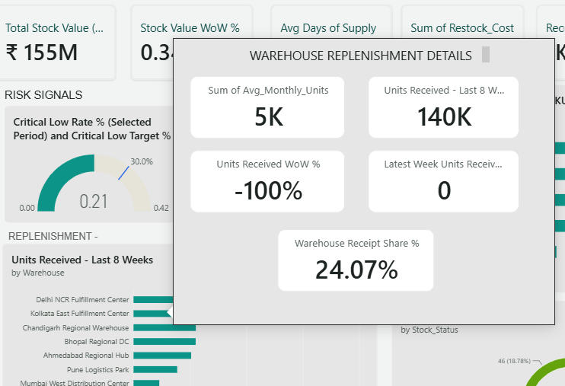

What the visual shows
The Warehouse Replenishment Details tooltip provides additional warehouse-level metrics when a user interacts with a warehouse in the Units Received – Last 8 Weeks visual. It displays average monthly units, units received over the last 8 weeks, week-over-week change in units received, latest-week units received, and the warehouse's receipt share percentage.
Why it is selected/included
The tooltip is included to provide deeper replenishment context without overcrowding the main chart. While the bar chart shows how many units each warehouse received, the tooltip helps users understand the selected warehouse's overall inbound volume, recent movement, latest activity, and contribution to total warehouse receipts.
What happens when interacted with
When the user hovers over a warehouse, the tooltip dynamically updates to show the detailed replenishment metrics for that specific warehouse. This creates a contextual drill-down experience, allowing users to assess warehouse performance without navigating away from the main inventory-flow analysis.

Stock Status SKUs

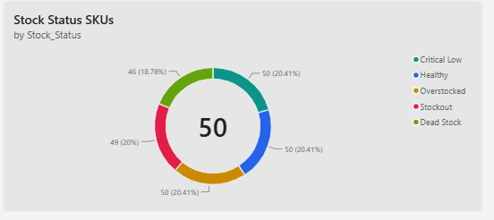

What the visual shows
This donut chart shows the distribution of SKUs across five inventory health statuses: Critical Low, Healthy, Overstocked, Stockout, and Dead Stock. It provides a quick view of how the overall SKU portfolio is distributed across healthy and risk-related inventory conditions.
Why it is selected/included
The visual is included to provide an at-a-glance assessment of inventory health. It helps management understand the balance between healthy inventory and potential issues such as low stock, stockouts, excess inventory, and dead stock, supporting better replenishment and inventory-optimization decisions.
What happens when clicked
When the user clicks on a stock-status segment, that status is highlighted and the connected visuals can cross-filter or cross-highlight based on the selected status. This allows users to investigate the categories, warehouses, and inventory movements associated with a particular stock condition.

Page 4 — 04 Network: Supplier & Warehouse Network

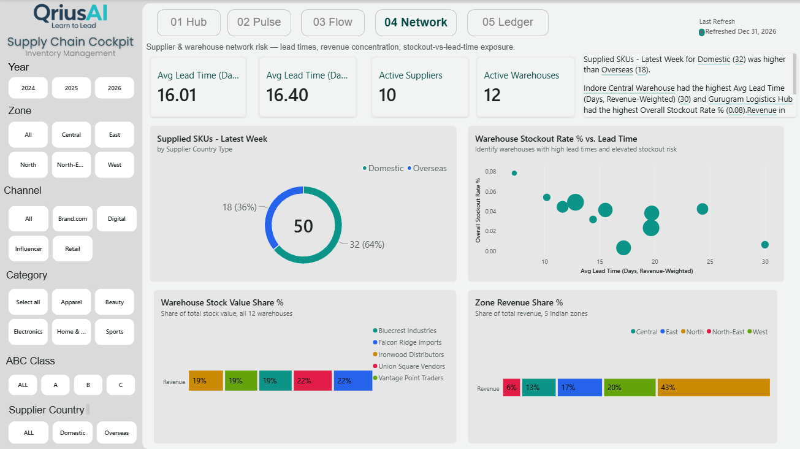

1. Page Overview
The 04 Network page focuses on the supplier and warehouse network, with emphasis on lead times, stockout exposure, supplier mix, warehouse concentration, and zone-level revenue distribution.
While 03 Flow focuses on how inventory is moving and being replenished, 04 Network answers:
“How resilient and efficient is our supplier and warehouse network, and where are we exposed to supply-chain risk?”
The page connects supplier performance, warehouse lead time, stockout risk, inventory concentration, and geographic revenue concentration to provide a network-level view of supply-chain health.

2. Business Problem
A supply chain can experience operational risk even when overall inventory levels appear healthy. Long supplier lead times, warehouse stockouts, supplier dependency, and geographic concentration can create vulnerabilities that are difficult to identify through inventory metrics alone.
Management needs visibility into:
- How long suppliers take to fulfill requirements.
- Whether lead times vary significantly across warehouses.
- Which warehouses have higher stockout exposure.
- How much of the SKU portfolio is supplied domestically versus overseas.
- Whether inventory value is concentrated among specific suppliers or warehouses.
- Which zones contribute the largest share of revenue.
- Where supply-chain dependencies could create operational risk.
Core Problem
How can supplier, warehouse, lead-time, stockout, and geographic concentration data be combined to identify network-level risks and improve supply-chain resilience?

3. Objective
The objective of 04 Network is to evaluate the strength, efficiency, and risk exposure of the supplier and warehouse network.
The page helps decision-makers:
- Monitor average supplier lead times.
- Compare overall and revenue-weighted lead times.
- Track active suppliers and warehouses.
- Identify warehouses with high stockout rates and long lead times.
- Understand the domestic vs overseas supplier mix.
- Identify concentration of stock value across suppliers/warehouses.
- Understand revenue concentration across geographic zones.
- Identify potential areas of supply-chain dependency and risk.

4. Business Questions Answered
Supplier & Warehouse Coverage
How many suppliers and warehouses are currently active?
The KPIs provide visibility into the scale of the operating network.
Lead-Time Performance
How long does it take for inventory to move through the supplier network?
The lead-time KPIs provide an overall view of supplier responsiveness.
Stockout Risk
Which warehouses combine high lead times with high stockout rates?
The Warehouse Stockout Rate % vs Lead Time scatter plot identifies warehouses where long replenishment times may be associated with greater stockout exposure.
Supplier Mix
How dependent are we on domestic versus overseas suppliers?
The Supplied SKUs — Latest Week donut shows the distribution of supplied SKUs by supplier country type.
Network Concentration
Is inventory value concentrated among particular suppliers?
The Warehouse Stock Value Share % visual shows how stock value is distributed across the supplier/warehouse network.
Geographic Revenue
Which zones contribute most to overall revenue?
The Zone Revenue Share % visual identifies the relative revenue contribution of each operating zone.

5. Story of the Page
The page follows a Network Scale → Lead Time → Risk → Concentration → Geographic Exposure story.
Step 1 — Establish Network Scale
The top KPIs establish the size and responsiveness of the network:
Lead Time → Revenue-Weighted Lead Time → Active Suppliers → Active Warehouses
This gives management an immediate understanding of how large the network is and how efficiently it operates.

Step 2 — Understand Supplier Composition
The Supplied SKUs — Latest Week visual compares Domestic and Overseas supplier contribution.
This provides insight into the sourcing structure and helps management understand the balance between domestic and international supply.

Step 3 — Identify Stockout Exposure
The Warehouse Stockout Rate % vs Lead Time scatter plot is one of the key risk-analysis visuals on this page.
It compares:
Lead Time ↔ Stockout Rate
This allows users to identify warehouses where longer lead times and higher stockout rates occur together, creating potential supply-risk hotspots.

Step 4 — Understand Network Concentration
The Warehouse Stock Value Share % visual shows how inventory value is distributed across the network.
This helps answer:
“Are we overly dependent on a small number of suppliers or warehouse locations?”
High concentration can represent a potential operational dependency that deserves monitoring.

Step 5 — Understand Geographic Revenue Exposure
The Zone Revenue Share % visual provides the commercial/geographic perspective by showing how total revenue is distributed across zones.
This helps management understand where business activity is concentrated and provides context for regional supply planning and network decisions.

6. Overall Page Takeaway
The 04 Network page moves the analysis from individual inventory operations to the structure and resilience of the supply-chain network itself.
The analytical journey is:
How large is our network?
↓
How efficiently does it operate?
↓
Where are lead-time and stockout risks?
↓
Where is inventory concentrated?
↓
Where is our revenue geographically concentrated?
Case Study Summary
04 Network provides a network-level view of supplier and warehouse performance, helping management identify lead-time exposure, stockout risk, sourcing dependencies, inventory concentration, and geographic concentration before they become larger supply-chain issues.

Page 4 — KPI Descriptions

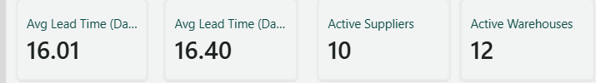

Avg Lead Time (Days) — Shows the average number of days required for inventory to move through the supplier network, indicating overall supply responsiveness.
Avg Lead Time (Days, Revenue-Weighted) — Shows the average lead time weighted by revenue, giving greater importance to products with higher revenue contribution.
Active Suppliers — Shows the number of suppliers currently contributing to the active supply network.
Active Warehouses — Shows the number of warehouses currently active in the supply-chain network.

Supplied SKUs — Latest Week

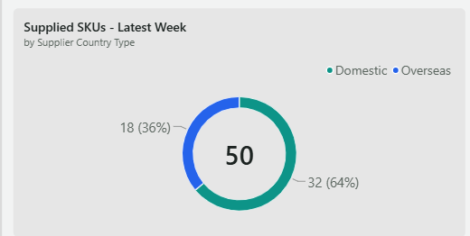

What the visual shows
This donut chart shows the distribution of supplied SKUs in the latest week by Supplier Country Type. It compares Domestic suppliers (64%, 32 SKUs) with Overseas suppliers (36%, 18 SKUs), giving a quick view of the sourcing mix.
Why it is selected/included
The visual is included to understand the supplier sourcing structure and potential geographic dependency within the network. It helps management assess the balance between domestic and overseas supply and identify whether the business relies more heavily on one sourcing type.

What happens when clicked
When the user clicks on Domestic or Overseas, the selected supplier type is highlighted and the connected visuals can cross-filter or cross-highlight based on that selection. This allows users to examine how the selected sourcing type relates to lead time, warehouse stockout risk, inventory value, and other network-level metrics.

Warehouse Stock Value Share %

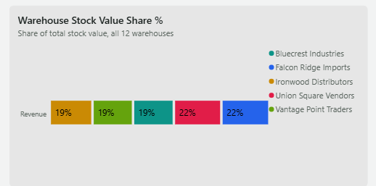

What the visual shows
This 100% stacked bar chart shows how the total inventory value is distributed across the warehouse network. It compares the stock value contribution associated with suppliers such as Bluecrest Industries, Falcon Ridge Imports, Ironwood Distributors, Union Square Vendors, and Vantage Point Traders, with each segment representing its percentage share of total stock value.
Why it is selected/included
The visual is included to identify inventory concentration within the warehouse network. It helps management understand whether stock value is evenly distributed or concentrated among particular suppliers/warehouse groups, which can highlight potential dependency and supply-chain concentration risks.
What happens when clicked
When the user clicks on a supplier segment, that supplier is highlighted and the connected visuals can cross-filter or cross-highlight based on the selection. This allows users to investigate the selected supplier's associated lead times, stockout risk, supplied SKUs, and network performance.

Zone Revenue Share %

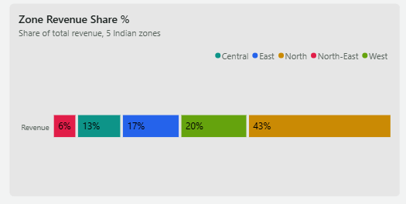
What the visual shows
This 100% stacked bar chart shows how total revenue is distributed across the five operating zones: Central, East, North, North-East, and West. It highlights the relative revenue contribution of each zone, with North contributing the largest share at 43%, followed by West at 20%.
Why it is selected/included
The visual is included to understand geographic revenue concentration and identify the regions that contribute most to business performance. This helps management assess regional dependency and supports decisions around resource allocation, inventory positioning, warehouse planning, and regional supply strategy.
What happens when clicked
When the user clicks on a zone segment, the selected zone is highlighted and the connected visuals can cross-filter or cross-highlight based on that selection. This allows users to investigate the selected zone's supplier network, warehouse performance, stockout exposure, lead times, and inventory-related metrics in greater detail.

Warehouse Stockout Rate % vs. Lead Time

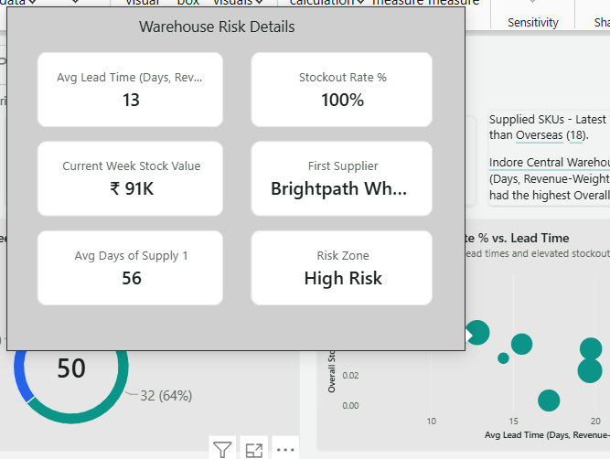
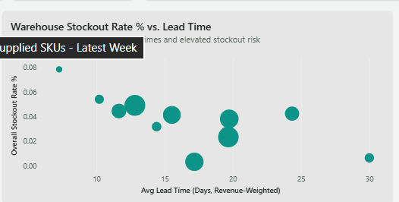
What the visual shows
This bubble scatter chart shows the relationship between revenue-weighted average lead time and overall stockout rate across warehouses. Each bubble represents a warehouse, allowing users to identify locations with higher lead times, higher stockout rates, or both.
Why it is selected/included
The visual is included to identify warehouse-level supply-chain risk. It helps management detect warehouses where longer lead times may be associated with higher stockout exposure and prioritize locations that require operational attention.
What happens when interacted with
When the user hovers over a warehouse bubble, the Warehouse Risk Details tooltip appears with additional information such as lead time, stockout rate, current-week stock value, supplier, days of supply, and risk zone. This allows users to move from a high-level risk comparison to a detailed warehouse-level diagnosis.

Page 5 — 05 Ledger: SKU-Level Detail & Risk Register

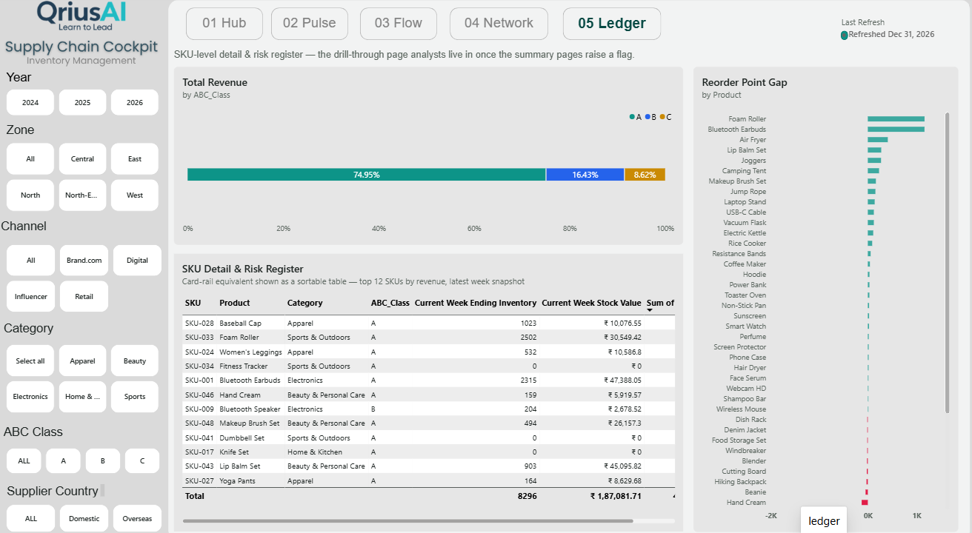
1. Page Overview
The 05 Ledger page is the detailed, operational layer of the Supply Chain Cockpit. It is designed for analysts and decision-makers who need to move from the high-level insights identified on the previous pages to specific SKU-level investigation.
While the earlier pages answer “What is happening across the supply chain?”, this page answers:
“Which specific products are responsible for the issue, and where should we take action?”
It combines ABC-class revenue concentration, SKU-level inventory details, and reorder-point gaps to create a detailed risk register.

2. Objective
The objective of 05 Ledger is to provide a SKU-level drill-down and risk register that helps users identify products requiring attention.
The page enables analysts to:
- Understand revenue concentration across ABC inventory classes.
- Review detailed SKU-level inventory and stock-value information.
- Identify products with potential reorder-point gaps.
- Compare current inventory levels with operational requirements.
- Prioritize products that may require replenishment or corrective action.

3. Business Problem
The summary pages provide valuable insights into overall inventory health, supplier performance, and warehouse risk, but aggregated metrics do not always reveal which individual products are creating the problem.
For example, identifying a stockout risk at the network level is only the first step. Operations teams need to know:
- Which SKU is affected?
- What product does it represent?
- Which category and ABC class does it belong to?
- How much inventory is currently available?
- What is the current stock value?
- Which products have a significant reorder-point gap?
Core Problem
How can high-level supply-chain risks be translated into actionable SKU-level information so that analysts can identify and prioritize the products requiring intervention?

4. Business Questions Answered
Revenue Concentration
How is revenue distributed across ABC inventory classes?
The Total Revenue by ABC Class visual shows the contribution of A, B, and C class products to overall revenue.
SKU-Level Inventory
Which products currently require attention?
The SKU Detail & Risk Register provides SKU-level information including product, category, ABC class, ending inventory, and current stock value.
Reorder Risk
Which products have the largest reorder-point gaps?
The Reorder Point Gap by Product visual highlights products where inventory position differs significantly from the required reorder level.
Prioritization
Which SKUs should operations investigate first?
By combining ABC classification, current inventory, stock value, and reorder-point gaps, the page helps users prioritize products based on their potential business impact.

5. Story of the Page
The page follows a Revenue Importance → SKU Detail → Risk Identification → Action story.
Step 1 — Understand Business Importance
The ABC Class revenue distribution establishes which class of products contributes most to revenue.
This is important because not every SKU carries the same business importance.
A-class products generally deserve greater attention because they represent a larger share of business value.
Step 2 — Drill Down to Individual SKUs
The SKU Detail & Risk Register then moves from aggregated performance to individual products.
Users can review:
SKU → Product → Category → ABC Class → Inventory → Stock Value
This provides the operational context required to investigate individual products.
Step 3 — Identify Reorder Gaps
The Reorder Point Gap by Product visual highlights products where current inventory may not align with the desired reorder level.
This helps identify potential replenishment priorities and inventory risks.
Step 4 — Move Toward Action
The final purpose of the page is prioritization.
Instead of simply saying:
“There is an inventory risk.”
the dashboard enables the analyst to determine:
“This specific SKU is affected, this is its inventory position, this is its business classification, and this is the size of its reorder gap.”

6. Overall Page Takeaway
The 05 Ledger page acts as the drill-down and action layer of the Supply Chain Cockpit.
The analytical journey is:
Which products matter most?
↓
What is their current inventory position?
↓
Which products have reorder risks?
↓
Which SKUs should be prioritized for action?
Case Study Summary
05 Ledger converts high-level supply-chain insights into SKU-level actionable intelligence, enabling analysts to identify important products, assess their current inventory position, detect reorder-point gaps, and prioritize replenishment actions.

Total Revenue by ABC Class

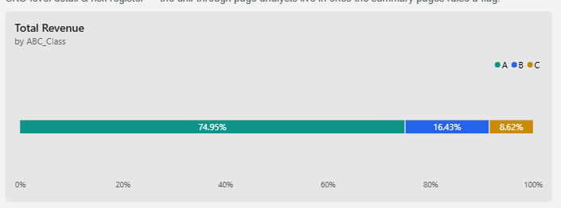

What the visual shows
This 100% stacked bar chart shows the distribution of total revenue across the three ABC inventory classes. Class A contributes 74.95%, Class B contributes 16.43%, and Class C contributes 8.62% of total revenue.
Why it is selected/included
The visual is included to understand revenue concentration and business importance across ABC classes. It helps identify where the majority of revenue is generated and supports prioritization of inventory management, replenishment, and risk monitoring efforts.
What happens when clicked
When the user clicks on an ABC class segment, that class is highlighted and the connected SKU Detail & Risk Register and other page elements can be filtered or highlighted accordingly. This allows the analyst to move from the overall revenue distribution to the specific SKUs belonging to the selected ABC class and investigate their inventory position and risk.
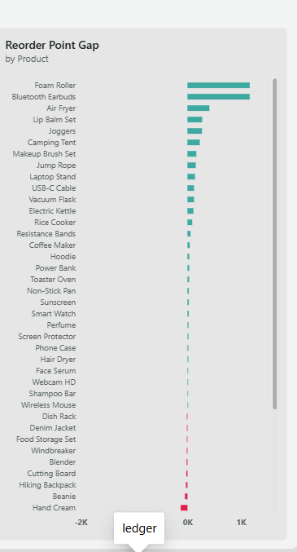

Reorder Point Gap
What the visual shows
This horizontal bar chart shows the reorder point gap for individual products. It compares the current inventory position against the required reorder level, highlighting products with positive gaps as potential replenishment needs and products with negative gaps as potential excess or lower replenishment requirements.
Why it is selected/included
The visual is included to identify product-level replenishment priorities. It helps operations teams quickly determine which products have the largest gaps and may require immediate attention, reducing the risk of stockouts while supporting more efficient inventory planning.
What happens when clicked
When the user clicks on a product, that SKU is selected and the connected SKU Detail & Risk Register can be filtered or highlighted to show its category, ABC class, current inventory, and current stock value. This allows the analyst to move directly from identifying a reorder gap to understanding the detailed business context of that product.
SKU Detail & Risk Register

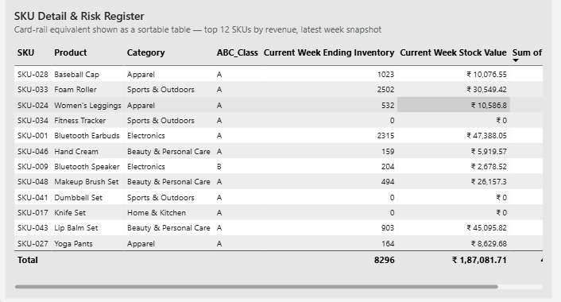

What the visual shows
This sortable table provides a detailed SKU-level view of the top 12 products by revenue in the latest week. It displays each SKU's product, category, ABC class, current-week ending inventory, and current-week stock value, giving a consolidated view of product-level inventory position.
Why it is selected/included
The table is included to provide the detailed operational information required for action after risks are identified in the dashboard. It helps analysts understand which specific products are involved, their inventory levels, business classification, and financial value, making it easier to prioritize replenishment and inventory-risk decisions.
What happens when clicked
The table is sortable, allowing users to click column headers such as SKU, Product, Category, ABC Class, Ending Inventory, or Stock Value to reorder the information. Selecting a row or SKU can also interact with other visuals through cross-filtering or highlighting, depending on the dashboard configuration, allowing deeper investigation of the selected product's reorder gap and inventory risk.

Conclusion
The Supply Chain Cockpit provides a comprehensive, data-driven view of the organization’s supply chain by connecting business performance, sales trends, inventory health, network risk, and SKU-level operations into a single analytical solution.
The dashboard follows a structured journey from high-level monitoring to detailed decision-making. The 01 Hub establishes the overall business health through revenue, profit, margin, and inventory indicators. 02 Pulse provides a deeper understanding of sales performance by analyzing quarterly comparisons, rolling revenue trends, category mix, and channel contribution. 03 Flow shifts the focus to inventory health by monitoring stock value, days of supply, replenishment activity, risk signals, warehouse receipts, and SKU status.
The analysis then moves to the supply-chain network through 04 Network, where lead times, stockout exposure, supplier sourcing, inventory concentration, and geographic revenue distribution help identify potential network vulnerabilities. Finally, 05 Ledger converts these high-level findings into SKU-level actionable information, allowing analysts to examine ABC classification, inventory position, stock value, and reorder-point gaps.
A key strength of the solution is that it does not stop at “what happened?”. Through interactive filters, cross-highlighting, bookmarks, tooltips, risk indicators, and drill-down-style analysis, it helps answer “why is it happening?” and “where should we act?”
Final Case Study Conclusion
The Supply Chain Cockpit transforms fragmented supply-chain data into a connected decision-support system. By bringing together financial performance, demand trends, inventory movement, supplier and warehouse risks, and SKU-level details, the dashboard enables management to identify risks earlier, understand their business impact, and prioritize operational actions. The solution ultimately supports better inventory availability, more efficient replenishment, improved supply-chain visibility, and more informed data-driven decision-making.

